Preference

It’s a pleasure to present the report “**Find out PNEUMONIA based on Chest X ray images by CNN of deep learning**” as the final project proposal as the part of our Final Project Presentation.

It’s a machine learning based project which will solve the timing problem of finding out pneumonia of chest from X-ray images.

Background & Justification of the project

Pneumonia is an illness, usually caused by infection, in which the lungs become inflamed and congested, reducing oxygen exchange and leading to cough and breathlessness. It affects individuals of all ages but occurs most frequently in children and the elderly. Among children, pneumonia is the most common cause of death worldwide. Historically, in developed countries, deaths from pneumonia have been reduced by improvements in living conditions, air quality, and nutrition. In the developing world today, many deaths from pneumonia are also preventable by immunization or access to simple, effective treatments. However, as we highlight here, there are critical gaps in our understanding of the epidemiology, etiology, and pathophysiology of pneumonia that, if filled, could accelerate the control of pneumonia and reduce early childhood mortality.[1]

Every year 1.9 million children under 5 years of age die from pneumonia[2]. Indeed, it is the leading cause of child death in the world. Pneumonia is an acute illness in which the alveolar air spaces of the lung become inflamed and filled with fluid and white blood cells, giving rise to the appearance of consolidation on the chest radiograph. It can be caused by bacterial, viral, or parasitic infection as well as by noninfectious agents. Most severe cases of pneumonia are caused by bacteria, of which the most important are Streptococcus pneumoniae (pneumococcus) and Haemophilus influenzae. In developing countries, where patients are often treated without seeing a doctor, the WHO defines clinical pneumonia simply as an acute episode of cough or difficulty breathing associated with an increased respiratory rate [3].

Pneumonia is a disease of all ages, and in adult medical wards across the developing world it is one of the most common admission diagnoses. In contrast to the industrialized world, pneumonia is found characteristically in younger adults, who have a substantial inpatient mortality of 5%–23% .[4] The pathogens causing pneumonia in children and adults are similar, and most respiratory pathogens are transmitted effectively between generations within households. In the United States, preventing pneumonia in children by vaccinating against pneumococcal disease has resulted in less pneumonia in adults [5]. However, little is known about adult pneumonia in developing countries, and research is rare outside the context of emerging infections. There are thus considerable opportunities for pneumonia research on adults. However, in this Review, we concentrate on childhood pneumonia and specifically on research to reduce the unacceptable magnitude of child deaths from this disease.

Historically, pneumonia was the main cause of child death in developed countries, and in the United States in 1900, it is estimated that pneumonia killed 47 of every 1,000 children before the age of 5 years [6]. Improvements in nutrition and living standards in the United States in the first 40 years of the 20th century led to a substantial reduction in pneumonia mortality well before antibiotics became available as an effective. However, in the low-income countries of Asia and Africa, pneumonia is still the main cause of child death. In developing countries, over one-quarter of children have an episode of clinical pneumonia each year throughout the first 5 years of their lives [7]. On average, 2%–3% of children each year have pneumonia severe enough to require hospitalization, and many of these disease episodes are potentially fatal. Thus, for every 1,000 children born, about 100–150 episodes of severe pneumonia arise during the first 5 years of life, most during the first 2 years. Approximately 21% of child deaths are due to pneumonia, and many developing countries have mortality rates of 60–100 per 1,000 children under 5 years of age; this suggests that of every 1,000 children born alive, 12–20 die from pneumonia before their fifth birthdays. [8]

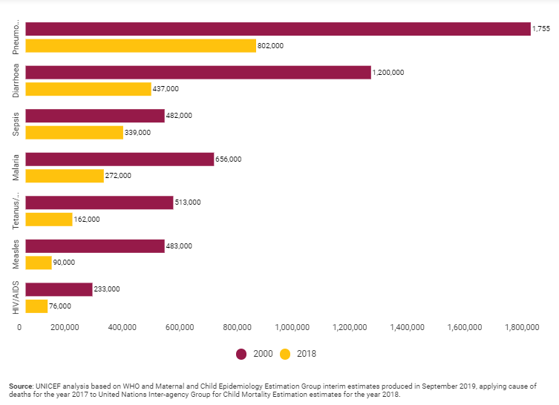

From the above graph we can see the death rate of children between 2000 to 2018.[9]

So here we want to work. The finding out Pneumonia from X-ray report by individual person or doctor is quite difficult and a lengthy process. For a doctor it takes time and huge experience to find out this. So, we want to develop a system which will solve this problem.

Objective

Here we come to the objective. We want to use software for making life easier & attentive. So here we want to make this software for that problem what we have mentioned in the “**Background & Justification**”. We want to solve this problem so that doctors can easily find out the problem and can take steps before it’s too late.

We are going to do build a system by machine learning approach to find out weather a patient has pneumonia or not from input X-ray report.

There will be two datasets:

1. Normal X-ray Images
2. Pneumonia X-ray Images

We will train the system by almost 3500 X-ray images of Pneumonia and 1300 normal X-ray images where the patient has no Pneumonia.

The working methods of this system will be described in the working section.

Features

* Detecting pneumonia in the critical stage of diagnosis can be life threatening. So, this will be easier way to find out pneumonia before that.
* Deep learning techniques ease the process of pneumonia identification process.
* Radiologists find it beneficial to distinguish chest X-ray images among absence or presence of pneumonia.
* Mask-RCNN configures regional context which helps finding accurate results.

Dataset

**Dataset:**

Dataset Name: Chest X-Ray Images (Pneumonia)

Dataset Link: Chest X-Ray Images (Pneumonia) Dataset (Kaggle)

**Dataset Details:**

Dataset Name: Chest X-Ray Images (Pneumonia)

Number of Class: 2

Number/Size of Images:

* Total: 5216 files (1.08 Gigabyte (GB))
* Training: 5216 files (1.07 Gigabyte (GB))
* Pneumonia: 3875 files (0.318 Gigabyte (GB))
* Normal: 1341 files (0.782Gigabyte (GB))

**Project Duration:**

* Duration: November 2019 - Current
* Length: Approx. 3 months.

Flow Charts

Machine Learning approach:

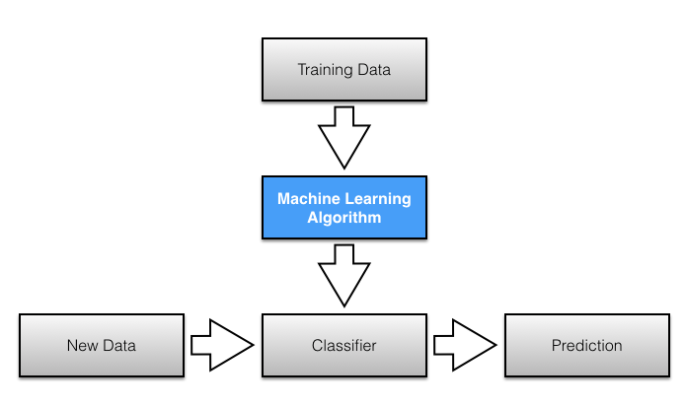

Predicted flow chart of our system:

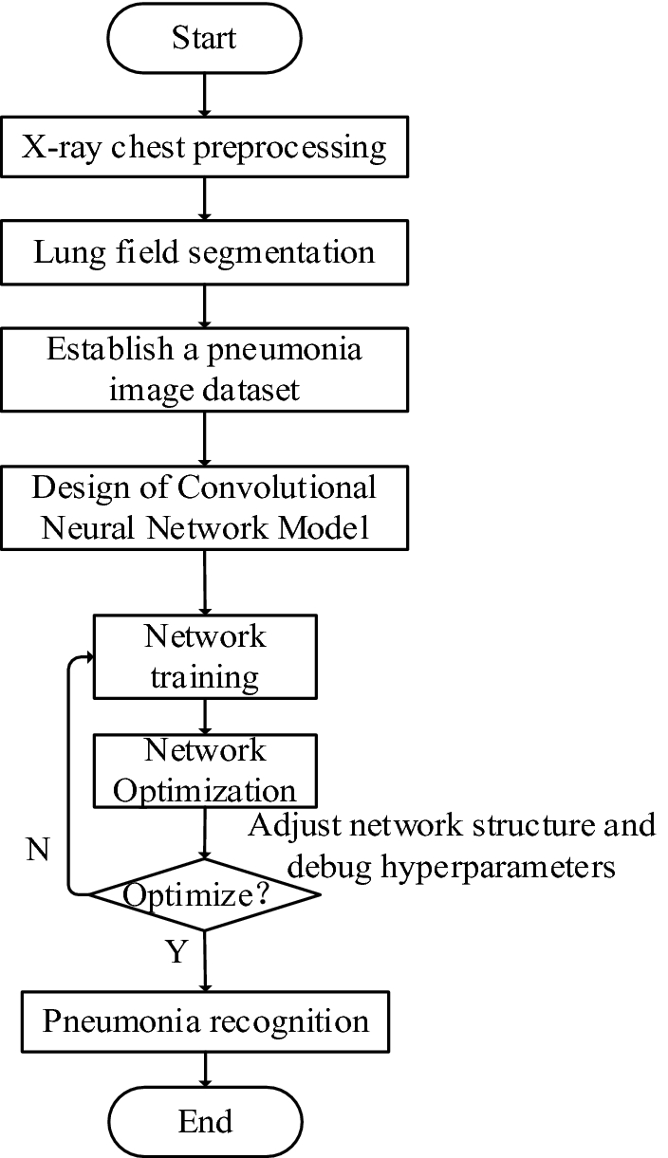

Conclusion

“**Engineering for change- By Engineers, for all**” this is our motivation.

We are trying to make this system for all according to that motivation. We here to develop such a system to prevent pneumonia death. We are here to make this software; so that doctors can take less time to find out pneumonia and can take actions immediately.

We thank our supervisor cordially for his help and detailed. We are very lucky to have him as our Project Supervisor. Thanks to all.

References:

1. Williams B.G., Gouws E., Boschi-Pinto C., Bryce J., Dye C. Estimates of world-wide distribution of child deaths from acute respiratory infections. Lancet Infect. Dis. 2002;2:25–32

2. WHO Programme for Control of Acute Respiratory Infections. 1990. Acute respiratory infections in children: case management in small hospitals in developing countries. A manual for doctors and other senior health workers. WHO. Geneva, Switzerland. 74 pp

3. Scott J.A., et al. Aetiology, outcome, and risk factors for mortality among adults with acute pneumonia in Kenya. Lancet. 2000;355:1225–1230.

4. Metlay J.P., Fishman N.O., Joffe M., Edelstein P.H. Impact of pediatric vaccination with pneumococcal conjugate vaccine on the risk of bacteremic pneumococcal pneumonia in adults. Vaccine. 2006;24:468–475.

5. Preston, S.R., and Haines, M.R. 1991.*Fatal years – child mortality in late 19th century America.* Princeton University Press. Princeton, New Jersey, USA. 4–5.

6. Grove, R.D., and Hetzel, A.M. 1968.*Vital statistics rates in the United States, 1940–1960.* US Department of Health, Education and Welfare, Public Health Service. Washington, DC, USA. 478–479.

7. Linder, F.E., and Grove, R.D. 1947.*Vital statistics rates in the United States, 1900–1940.* United States Government Printing Office. Washington, DC, USA. 254–255.

8. Mulholland K. Perspectives on the burden of pneumonia in children. Vaccine. 2007;25:2394–2397.

9. Rudan I., Tomaskovic L., Boschi-Pinto C., Campbell H. Global estimate of the incidence of clinical pneumonia among children under five years of age. Bull. World Health Organ. 2004;82:895–903.

10. UNICEF. 2007. State of the World’s Children. New York: United Nations Children’s Fund.

11. Cherian T., et al. Standardized interpretation of paediatric chest radiographs for the diagnosis of pneumonia in epidemiological studies. Bull. World Health Organ. 2005;83:353–359.

12. Background Paper 6.22 Pneumonia by Nga Tong, BA, MPH (May 2013) by WHO.

13. Scott J.A., Hall A.J. The value and complications of percutaneous transthoracic lung aspiration for the etiologic diagnosis of community-acquired pneumonia. Chest. 1999;116:1716–1732.

14. Shann F., et al. Aetiology of pneumonia in children in Goroka Hospital, Papua New Guinea. Lancet. 1984;2:537–541.

15. Adegbola R.A., et al. The etiology of pneumonia in malnourished and well-nourished Gambian children. Pediatr. Infect. Dis. J. 1994;13:975–982.

16. Lee W.M., et al. High-throughput, sensitive, and accurate multiplex PCR-Microsphere flow cytometry system for large-scale comprehensive detection of respiratory viruses. J. Clin. Microbiol. 2007;45:2626–2634.

17. Fan J., Henrickson K.J., Savatski L.L. Rapid simultaneous diagnosis of infections with respiratory syncytial viruses A and B, influenza viruses A and B, and human parainfluenza virus types 1, 2, and 3 by multiplex quantitative reverse transcription-polymerase chain reaction-enzyme hybridization assay (Hexaplex). Clin. Infect. Dis. 1998;26:1397–1402.

------------------------------